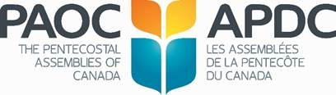

**2022 General Conference**

**Sponsorship Application Form**

____________________________________ (name of organization) would like to be a sponsor of the PAOC 2022 General Conference at Calvary Temple, Winnipeg, MB from May 16-18, 2022. Please send an invoice for the sponsorship opportunities outlined below.

**Organization Contact Information**

|  |  |
| --- | --- |
| Contact Person |  |
| Address |  |
| Phone Number |  |
| Fax Number |  |
| Email Address |  |

**(x) Sponsorship Level**

|  |  |  |
| --- | --- | --- |
|  | Platinum | $10,000 |

|  |  |  |
| --- | --- | --- |
|  | Gold | $5,000 |

|  |  |  |
| --- | --- | --- |
|  | Silver | $1,500 |

**Mail, scan or fax to: Colleen Stuckless**

The Pentecostal Assemblies of Canada

2450 Milltower Court

Mississauga, ON L5N 5Z6

Phone: 905-542-7400 Fax: 905-542-7313

colleen.stuckless@paoc.org